|  |
| --- |
| **Homeostasis -** Practice Examination Questions |

**Multiple-Choice Section (20 marks)**

Suggested working time is 20 minutes

_________________________________________________________________________

1. Which of the following lists describes the components of the steady state control system involved in maintaining the body temperature within a set range in the correct order?
2. change in body temperature, chemoreceptors in carotid body, medulla, diaphragm and intercostal muscles, negative feedback.
3. change in temperature of the environment, thermoreceptors in skin and the brain, hypothalamus, blood vessels, change in the diameter of the blood vessels, negative feedback.
4. change in body temperature, thermoreceptors in skin and brain, hypothalamus, blood vessels, change in diameter of blood vessels, negative feedback.
5. change in body temperature, pressoreceptors in aorta, medulla, skeletal muscles, shivering, positive feedback.
6. Researchers compared the survival rates of people subjected to temperatures beyond normal tolerance range for humans. People whose temperature was raised above normal by 6-7°C for some time almost died. Those who had been immersed in icy water causing their temperature to decrease by 6-7°C usually survived. This is because:
7. low temperatures reduce the water output and effects of dehydration allowing the body to return to normal quickly.
8. the metabolic rate cannot keep up with the body requirements at high temperatures due to the denaturation of enzymes.
9. the metabolic rate at high temperatures produces large amounts of wastes that cannot be removed therefore producing a toxic effect on cells.
10. heat transfer to a cold person is much more efficient than heat transfer from a hot person.
11. Gluconeogenesis is the conversion of:
12. glucose into glycogen
13. glycogen into glucose
14. amino acids and fatty acids into glucose
15. glucagon into glycogen
16. Rising osmotic pressure in the blood is detected by the

(a) medulla and stimulates the release of more antidiuretic hormone

(b) hypothalamus which releases less antidiuretic hormone

(c) hypothalamus and stimulates the posterior pituitary to release more antidiuretic hormone

(d) posterior pituitary stimulates the adrenal gland to release more antidiuretic hormone

1. A person suffering water intoxication has consumed too much water in a short period of time. What effect would this have on the blood plasma and nephron tubules?
2. increased osmotic pressure of the blood and increased water reabsorption from the nephron tubules into the blood plasma.
3. decreased osmotic pressure of the blood and decreased water reabsorption from the nephron tubules into the blood plasma.
4. increased water concentration of the blood and increased water reabsorption from the nephron tubules into the blood plasma.
5. decreased water concentration of the blood and decreased water reabsorption from the nephron tubules into the blood plasma.

**Question 6 refers to the diagram below of the nephron.**

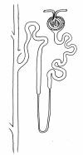

B

C

A

D

1. Identify the structures where the process of reabsorption occurs

(a) A only

(b) B only

(c) A and C

(d) A, C and D

1. Hyperventilation is used by free divers to enhance their endurance. However, it may cause

1. unconsciousness, as the level of carbon dioxide in their blood is too low to trigger breathing
2. alveolar collapse, as the air sacs rupture from rapid breathing
3. a rapid heartbeat, which in turn, causes too much stress on the heart, and the person may have a heart attack
4. a feeling of euphoria, as the high level of oxygen gives you a ‘high’
5. The following statements refer to the control of blood sugar levels. Identify the **incorrect** response

(a) glycogen is broken down under the influence of the hormone glucagon

(b) glucose is stored under the influence of the hormone insulin

(c) glycogen is produced under the influence of the hormone insulin

(d) glycogen is produced under the influence of the hormone glucagon

1. Temperature regulation during intense physical activity is brought about by

(a) core receptors in the hypothalamus which then relays responses via the ANS to sweat glands and arterioles in the skin

(b) core receptors in the medulla which then relays responses via the ANS to sweat glands and arterioles in the skin

(c) core receptors in the pons which then relays responses via the ANS to sweat glands and arterioles in the skin

(d) sensors in the skin sending signals to the medulla which then relays responses via the ANS to sweat glands and arterioles

1. When the receptors of the hypothalamus detect an increase in concentration of blood solutes, the pituitary gland is stimulated and ADH is released. It would be reasonable to expect that:
2. drinking a large volume of water would increase production of ADH.
3. if there is low ADH in the body, then less urine is produced.
4. a decrease in salt concentration would cause a decrease in stimulation of the pituitary gland.
5. drugs which cause a decrease in urine production may act on the pituitary gland to decrease the secretion of ADH.
6. In an investigation of the human kidney the volume of urine produced by a group of volunteers was measured. For four days the group lived in a controlled environment with a constant room temperature of 22ºC and a fixed diet. The average volume of urine was 350 mL/day. For the next four days the average volume of urine produced by group members was 420 mL/day. What environmental factor/s would NOT explain the increase in urine production for the second four-day period?
7. greater fluid intake from day 5 onwards.
8. a compound added to the diet which reduces water absorption from the tubules.
9. an increase in room temperature from 22ºC to 27ºC from day 5 onwards.
10. a compound in the diet which increased glomerular filtration.
11. Increasing the carbon dioxide concentration in the blood will
    1. increase the pH of the blood.
    2. incur hyperventilation.
    3. stimulate a nervous impulse through the vagus nerve.
    4. trigger a response from the chemoreceptors before a decrease in oxygen concentration.

**Use the diagram below to answer Question 13**

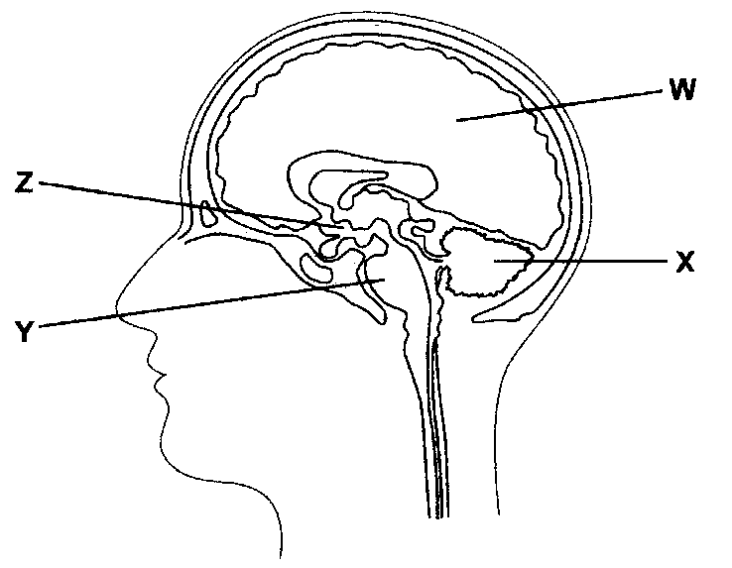

1. Which regions control balance, heart rate and temperature respectively?

|  |  |  |  |
| --- | --- | --- | --- |
|  | **Balance** | **Heart Rate** | **Temperature** |
| (a) | W | Z | X |
| (b) | X | Y | Z |
| (c) | Y | X | W |
| (d) | X | Z | Y |

1. The peripheral chemoreceptors are located in the

(a) carotid artery and aorta.

(b) hypothalamus.

(c) medulla oblongata.

(d) adrenal medulla.

1. Increasing the secretion rate of antidiuretic hormone (ADH) would cause the:
2. Urine to decrease in both volume and concentration
3. Immediate re-absorption of glucose, amino acids and sodium
4. Urine volume to decrease
5. Blood pressure to increase
6. Fewer hydrogen ions will be secreted into the urine when:
7. The blood pH increases
8. The blood pH decreases
9. Aldosterone is secreted
10. Antidiuretic hormone (ADH) is secreted

**The following information relates to Questions 17, 18 and 19.**

A patient has complained of the following symptoms to their doctor:

* Feeling a lack of energy
* Unexplained weight loss
* Frequently craving foods with sugar

In response, the doctor had the patient’s blood glucose levels tested over five consecutive days. The patient’s results, measured in millimoles per litre, can be seen in the table below.

|  |  |  |  |  |  |
| --- | --- | --- | --- | --- | --- |
| Day | 1 | 2 | 3 | 4 | 5 |
| Glucose concentration (mmol/L) | 4.0 | 4.3 | 4.9 | 4.7 | 5.1 |

A normal range is between 4 and 6 mmol/L

1. The mean glucose concentration in the patient’s bloodstream over the five days was
   1. 4.6
   2. 4.9
   3. 4.8
   4. 4.5
2. The percentage change in the patient’s blood glucose level from the first day to the fifth

day was a

* 1. 27.5% decrease.
  2. 21.5% increase.
  3. 27.5% increase.
  4. 21.5% decrease.

1. Which of the following patient’s glands and their respective hormones may be underactive?
   1. Alpha cells of the pancreas; glucagon.
   2. Adrenal cortex; cortisol.
   3. Alpha cell of the pancreas; insulin.
   4. Thyroid gland; ACTH.
2. Sally, a long-distance runner, took part in a laboratory test using a treadmill. She was asked to run at 8 km/hour for thirty minutes. Sally was allowed to rest for five minutes and then repeated the exercise three times. Her performance was similar on all four occasions even though her breathing rate increased greatly. The change in her breathing occurred due to:
   1. A decrease in the blood pH and this change was detected by the chemoreceptors located in the hypothalamus
   2. An increase in the blood pH and this change was detected by chemoreceptors located in the medulla oblongata
   3. A decrease in the blood pH and this change was detected by the chemoreceptors in the aortic and carotid bodies
   4. A decrease in the blood pH and this change was detected by the chemoreceptors in the aorta and carotid arteries

**Short Answer Section (29 marks)**

Suggested working time is 30 minutes

_________________________________________________________________________________

**Question 21 (6 marks)**

Janet is in her mid 40’s. She has always led a healthy, active lifestyle. She recently injured her knee and is currently fasting in preparation for a surgical procedure to repair her knee. She has not eaten for several hours and feels very hungry. Her doctor has assured her that her blood glucose levels are stable.

Describe the homeostatic mechanism that will allow her blood glucose to remain stable throughout this time of fasting.

_________________________________________________________________________________________________________________________________________________________________________________________________________________________________________________________________________________________________________________________________________________________________________________________________________________________________________________________________________________________________________________________________________________________________________________________________________________________________________________________________________________________________________________________________________________________________________________________________________________________________________________________

**Question 22** **(18 marks)**

Free divers are athletes who descend underwater as far as possible without breathing apparatus. Before diving into the water, the free diver deliberately hyperventilates.

* 1. Hyperventilation can occur voluntarily or involuntarily. It can occur involuntarily in response to severe pain or extreme fear.

Complete the following table to distinguish between the two different efferent nervous divisions that can regulate hyperventilation. (5 marks)

|  |  |  |
| --- | --- | --- |
|  | Names of two different nervous efferent divisions | |
| 1.______________________ | 2. _____________________ |
| Neurotransmitters |  |  |
| Effector(s) / target organ(s) |  |  |
| Effect of neurotransmitter on  effector(s) / target organ(s) |  |  |
| The number of neurons  between the CNS and effector |  |  |

* 1. Explain how voluntary hyperventilation allows the free diver to stay underwater for longer.

(3 marks)

____________________________________________________________________________________________________________________________________________________________________________________________________________________________________________________________________________________________________________________________________________________________________________________________

* 1. Whether an individual hyperventilates or not, drowning can still occur if the individual is under the water and does not get to the surface in time to inhale. (4 marks)

Explain why a person could drown if they:

(i) did hyperventilate.

____________________________________________________________________________________________________________________________________________________________________________________________________________________________________

(ii) did not hyperventilate.

____________________________________________________________________________________________________________________________________________________________________________________________________________________________________

* 1. After hyperventilate, explain how CO2 levels would be restored to normal. (6 marks)

____________________________________________________________________________________________________________________________________________________________________________________________________________________________________________________________________________________________________________________________________________________________________________________________ ____________________________________________________________________________________________________________________________________________________________________________________________________________________________________________________________________________________________________________________________________________________________________________________________

**Question 23** **(5 marks)**

A marathon runner is just about to complete a race in hot weather and he is sweating, feels thirsty and his skin is red and hot.

1. Complete the following table to summarise the body’s symptoms to the exercise in the hot environment.

|  |  |  |  |  |  |
| --- | --- | --- | --- | --- | --- |
| **Symptoms** | **Stimulus** | **Receptor** | **Modulator** | **Effector** | **Response** |
| Red and  hot skin | Increased  body  temperature | Thermoreceptor | Hypothalamus |  |  |
| Sweating | Increased  body  temperature | Thermoreceptor |  | Sweat glands | Sweat released  onto the surface of  this skin |
| Thirsty | Increased  osmotic  pressure |  | Hypothalamus |  | Conscious decision  to have a drink |

**Extended Response (30 marks)**

Suggested working time is 30 minutes

_________________________________________________________________________________

**Question 24**

Discuss the changes that occur to the cardiovascular and respiratory system’s during exercise. Explain why they occur and any homeostatic mechanisms involved. (10 marks)

**Question 40** **(20 marks)**

Under normal circumstances, homeostatic control mechanisms ensure blood glucose levels (BGLs) are maintained at a constant level. People with diabetes mellitus are incapable of maintaining their BGLs and they can experience increased urination (polyuria) if they consume a meal high in glucose.

1. Explain how the pancreas and liver would reduce the BGLs in someone who was not a diabetic.

(5 marks)

1. Explain the cause and treatments of type 1 and type 2 diabetes. (6 marks)
2. The high amounts of glucose in a diabetic’s blood plasma can lead to a high osmotic pressure within the blood plasma.

Describe what effect this stimulus would have on the action of antidiuretic hormone (ADH) in controlling water balance and explain why a diabetic would urinate excessively and feel thirsty.

(9 marks)